**TEAM ID : PNT2022TMID40587**

Iot Based Signs with SmarConnectivity for Better Road Safety

Develop python script

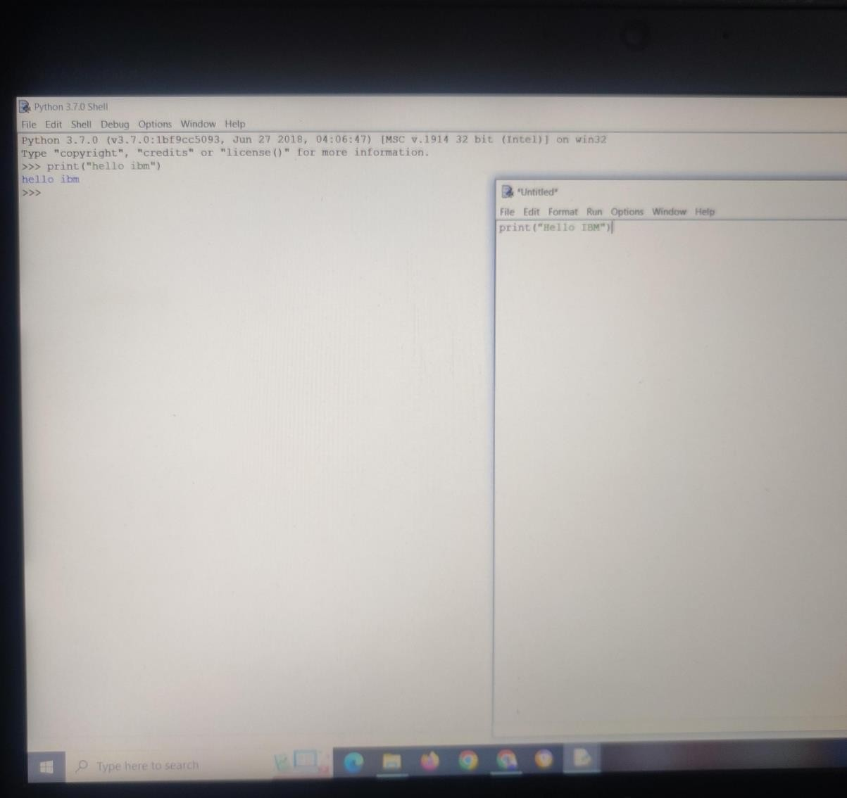

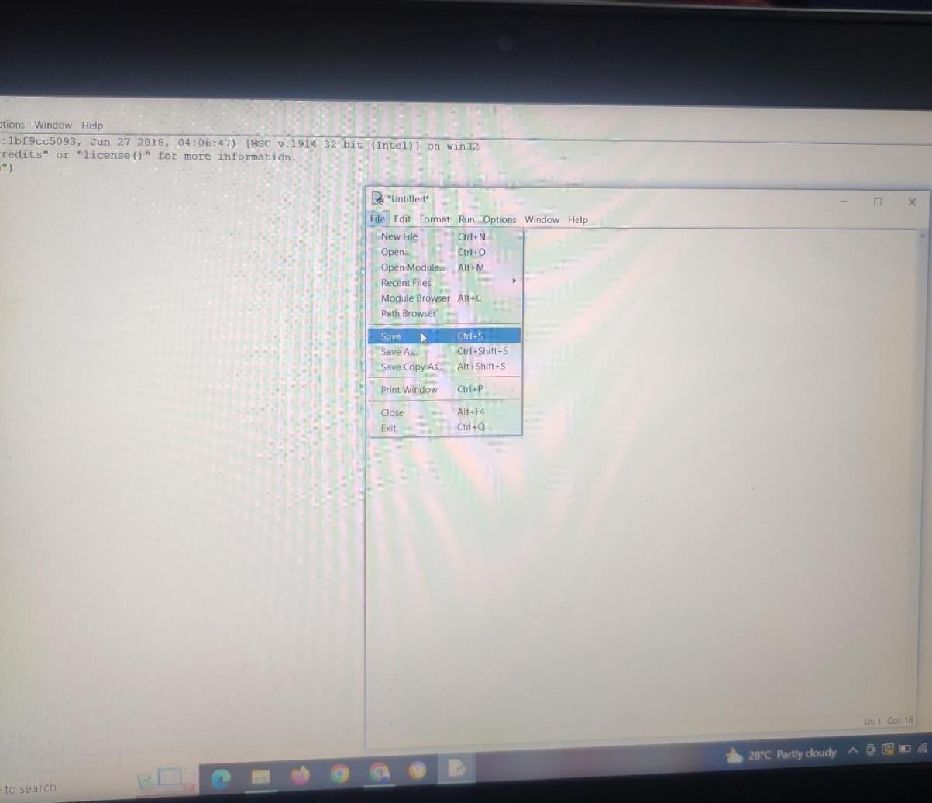

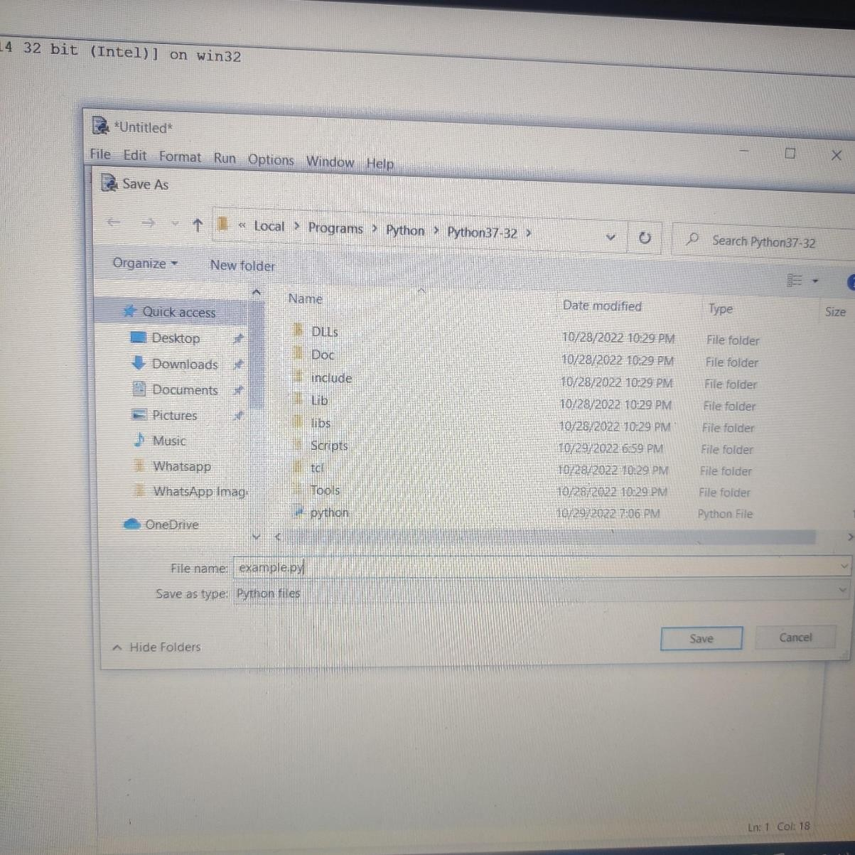

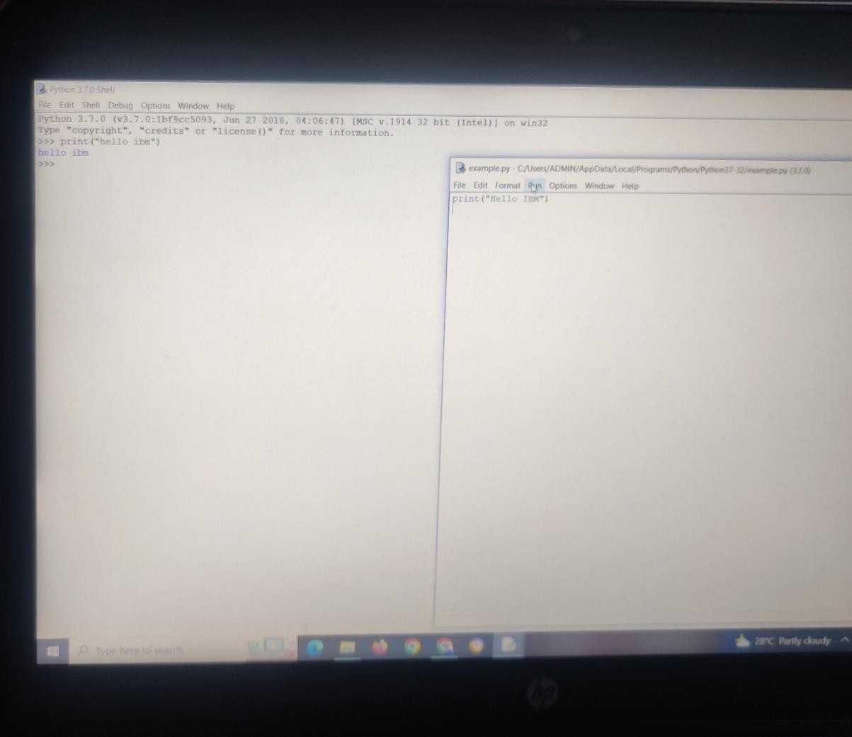

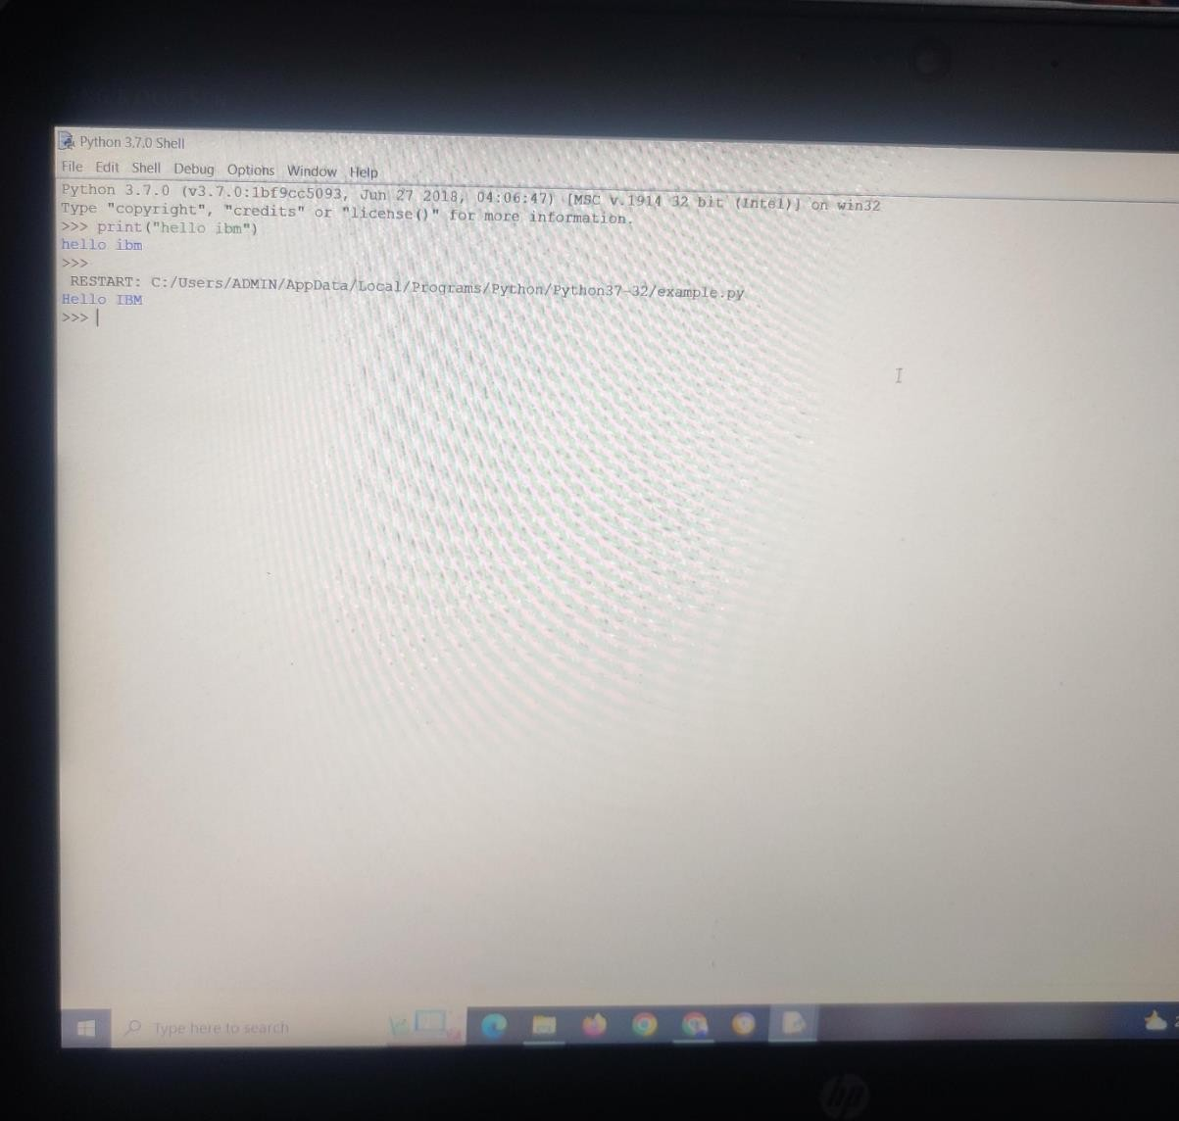

TEAM ID : PNT2022TMID40587 TEAM LEADER : PARTHIBAN N TEAM MEMBER 1 : ANANDHALAKSHMI S

TEAM MEMBER 2 : JEGANATHAN T

TEAM MEMBER 3 :TAMILARASAN TEAM SIZE : 4

MENTOR : Arularumugam